1. For given below corpus,
<S> Martin Justin can watch will </S>
<S> Spot will catch Martin </S>
<S> Will Justin spot Martin </S>
<S> Martin will pat spot </S>
N: Noun [Martin, Justin, will, Spot, Pat]
M: Model Verb [can, will]
V : Verb[watch, spot, pat]
Create Transition & Emission Probability matrix for statement “Justin will spot Will”. Apply Hidden Markov model and do POS tagging.

2. What is hybrid POS tagging ?
Hybrid POS (Part-of-Speech) tagging is a method that combines two or more different techniques, most commonly rule-based and statistical approaches, to tag words in a sentence with their grammatical roles like noun, verb, or adjective.
This approach aims to achieve higher accuracy by leveraging the strengths of each method, such as the precision of rules and the generalization of statistical models.
For instance, a system might use a statistical model to make an initial guess and then use a set of rules to correct errors or refine the tags.

Key characteristics of hybrid POS tagging:
- Combines different methods:
It integrates rule-based systems (which use manually defined rules) with statistical methods (which use probability and machine learning).
- Leverages strengths:
By combining approaches, it overcomes the limitations of any single method. For example, rule-based systems are precise but can be difficult to scale, while statistical systems can generalize but may make errors that rules can correct.
- Increases accuracy:
Hybrid systems often achieve higher accuracy than either a rule-based or a statistical model alone, especially for ambiguous words.
- Example workflow:
A common pattern is to use a statistical tagger (like a Hidden Markov Model or Conditional Random Field) to generate an initial set of tags, and then apply a set of transformation rules to correct errors.
- Used in specific scenarios:
Hybrid models are particularly useful for languages with limited data, where statistical models might not train well, or for tasks that require a high level of accuracy.

Example workflow (practical)
- Step 1: Tokenize and run morphological analyzer + lexicon lookup to get candidate tags.
- Step 2: Run a statistical tagger (CRF or BiLSTM-CRF) using lexicon features and local context to produce initial tags.
- Step 3: Apply transformation rules (learned or hand-crafted) to correct common systematic errors (e.g., change NN→VB if preceded by modal).
- Step 4: Run a consistency checker to enforce global constraints and finalize tags.

3. What is the difference between lexical ambiguity and sematic ambiguity ?
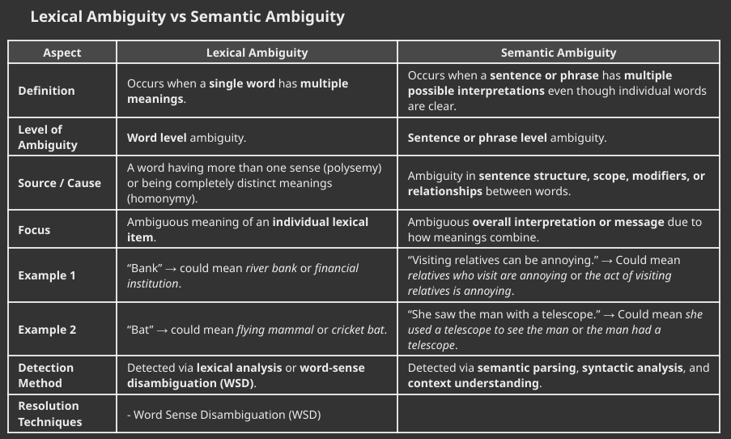

4. What is Word Sense Disambiguation (WSD)? Explain the dictionary based approach to Word Sense Disambiguation.
Introduction
Word Sense Disambiguation (WSD) is the process of determining the correct sense of a word used in a particular context. Since many words have multiple meanings, WSD helps machines interpret natural language correctly. The dictionary-based approach is one of the earliest and simplest methods to perform WSD.
Main Content
1. Definition of WSD
WSD identifies the intended meaning of a polysemous word in a given sentence using its context. It ensures accurate understanding of meaning in applications like machine translation, search engines, and summarization.
2. Example of Need for WSD
- “He went to the bank to deposit money.”
- “He sat on the bank of the river.”
The word bank has two senses: financial institution and river side. WSD determines which one applies.

3. Dictionary-Based Approach
This method uses dictionaries, thesauri, or lexical databases (like WordNet) that provide definitions, synonyms, and semantic relationships for words. WSD is achieved by comparing the overlap of context words with sense definitions.
4. Lesk Algorithm (Classical Example)
The Lesk algorithm (1986) is a dictionary-based technique that assigns a sense to a word whose definition shares the most words in common with the surrounding context.
Steps:
- For each ambiguous word, obtain all dictionary definitions (glosses).
- Collect the surrounding context words in the sentence.
- Measure overlap between gloss words and context words.
- Choose the sense with the highest overlap.

5. Example
Sentence: “He went to the bank to withdraw cash.”
- bank₁: “financial institution that accepts deposits”
- bank₂: “sloping land beside a river”
Context words: withdraw, cash → overlap higher with bank₁ → select financial institution sense.

5. Explain the various challenges in POS tagging.
Introduction
Part-of-Speech (POS) tagging assigns grammatical categories such as noun, verb, adjective, etc., to words in text. Despite significant progress, POS tagging faces challenges due to ambiguity, unseen words, and linguistic variation across domains and languages.
Main Content
1. Ambiguity of Words
Many words can belong to multiple POS categories depending on context. For example, “can” may be a modal (I can swim) or a noun (a can of soda). Resolving such ambiguities is a major difficulty.
2. Unknown or Out-of-Vocabulary (OOV) Words
Words not found in the training data (like new names or slang) make tagging uncertain. Taggers must use morphological and contextual clues to guess their categories.
3. Domain Variation
Models trained on one domain (e.g., news) perform poorly on another (e.g., social media) due to different vocabulary and grammatical usage.
4. Context Sensitivity
Words depend heavily on neighboring words. For example, “light” can be a noun, verb, or adjective depending on context. Context modeling errors reduce tagging accuracy.
5. Multiword Expressions
Idioms or collocations like “kick the bucket” cannot be tagged correctly if analyzed word-by-word. Identifying such expressions is challenging.
6. Ambiguous Proper Nouns
Names such as “Will” or “March” may appear as nouns or verbs. Taggers often confuse them if capitalization or punctuation is inconsistent.
7. Morphologically Rich Languages
In languages like Hindi or Marathi, a single word form can encode multiple grammatical categories. Handling these forms increases complexity.
8. Lack of Annotated Data
Supervised taggers require labeled corpora. For low-resource languages, the scarcity of annotated data limits performance.
9. Errors from Tokenization
Incorrect token boundaries (like punctuation handling) can cause incorrect tagging downstream.
Conclusion
POS tagging challenges arise from linguistic ambiguity, limited data, and contextual dependence. Continuous improvements in hybrid, neural, and transfer learning approaches help modern NLP systems handle these issues more accurately.
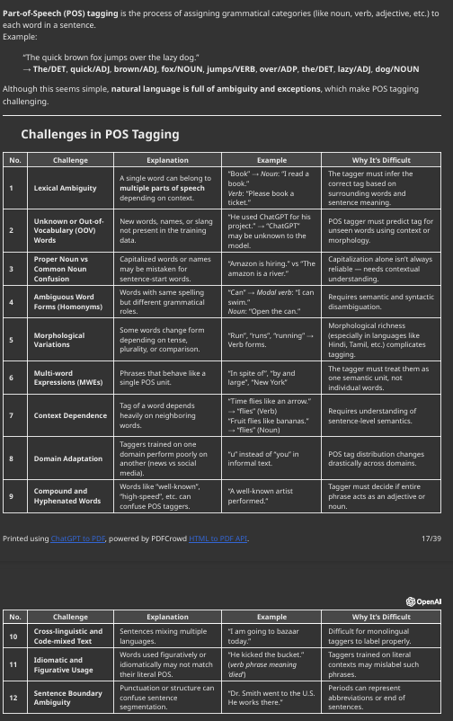

6. Explain Top-down & Bottom-up approach of parsing with suitable example.
Parsing is the process of analyzing a sentence (or string of tokens) to determine its grammatical structure
according to a given grammar (usually Context-Free Grammar — CFG).
- Input: Sequence of words/tokens
- Output: Parse tree (showing syntactic structure)
Parsing helps NLP systems understand how words combine to form phrases and sentences

Definition:
Top-down parsing starts from the start symbol (root) of the grammar and tries to derive the input string by expanding non-terminals until the input is generated.
It works by predicting what the input should be, based on grammar rules.

Process Steps:
1. Begin with the start symbol (S).
2. Expand (substitute) non-terminals using production rules.
3. Compare generated symbols with the input tokens (from left to right).
4. If mismatch → backtrack and try another production.
5. Continue until:
Input string is fully matched → ✅Success
All options exhausted → ❌Failure

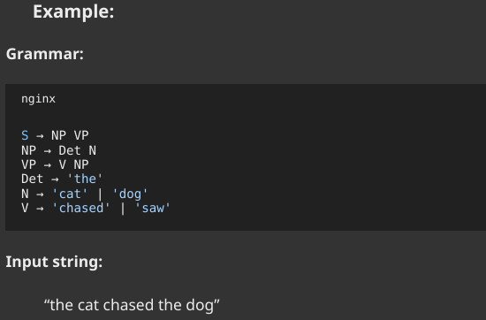

Definition:
Bottom-up parsing starts from the input tokens and reduces them step-by-step into higher-level syntactic
categories until reaching the start symbol (S).
It works by recognizing what the input is and combining it according to grammar rules.

Process Steps:
1. Start with the input string (tokens).
2. Identify substrings that match the right-hand side (RHS) of grammar rules.
3. Replace (reduce) them with the left-hand side (LHS) non-terminal.
4. Continue reducing until:
- The start symbol (S) remains → ✅ Success
- No valid reduction possible → ❌ Failure
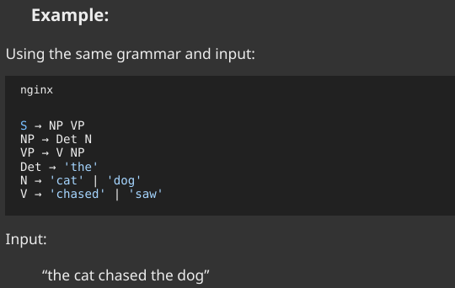
7. Consider the following corpus
<s> the/DT students/NN pass/V the/DT test/NN<\s>
<s> the/DT students/NN wait/V for/P the/DT result/NN<\s>
<s> teachers/NN test/V students/NN<\s>
Compute the emission and transition probabilities for a bigram HMM. Also decode the given sentence using Viterbi algorithm. "The students wait for the test".

8. Explain with suitable examples the following relationships between word meanings:
Hyponymy, Polysemy, Homonymy and Synonymy.
Words are connected by various semantic relationships that describe meaning similarities and differences. Key relationships include hyponymy, polysemy, homonymy, and synonymy — all fundamental to lexical semantics and WordNet-based NLP.
1. Hyponymy
Hyponymy is a hierarchical relationship where the meaning of one word (the hyponym) is included in the meaning of another word (the hypernym).
- Hyponym: A more specific term.
- Hypernym (superordinate): A more general term.
👉It expresses a “is-a-type-of” relationship
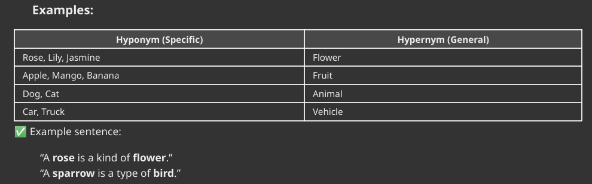
2. Polysemy
Polysemy occurs when a single word has multiple related meanings or senses. These meanings share a common origin or conceptual connection.
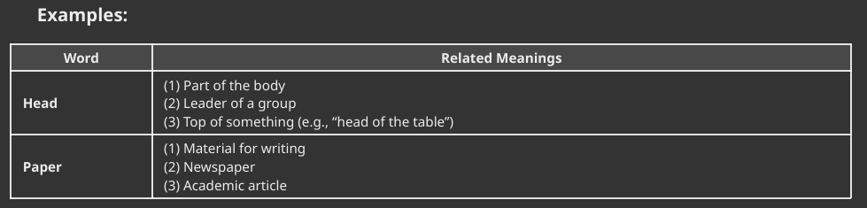
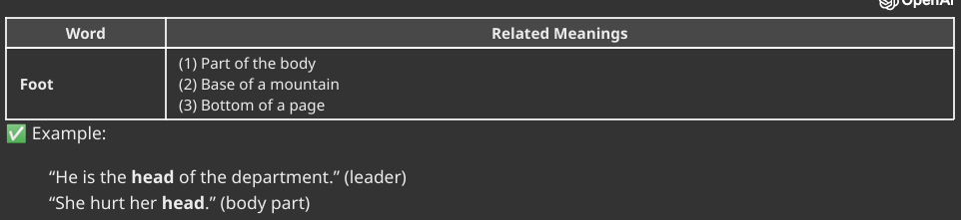
Polysemy is common in natural languages and adds richness to vocabulary.
3. Homonymy
Homonymy occurs when two words have the same spelling or pronunciation but entirely unrelated meanings(different origins).
Homonyms can be of two types:
- Homographs: Same spelling, different meanings (may or may not sound alike)
- Homophones: Same sound, different meanings (may or may not be spelled alike)
Homonyms create lexical ambiguity.
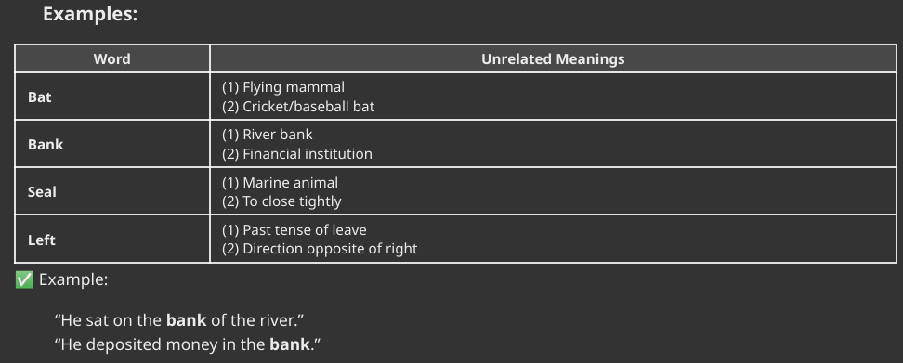

4. Synonymy
Synonymy refers to the relationship between two or more words that have similar or nearly identical meanings in some contexts.
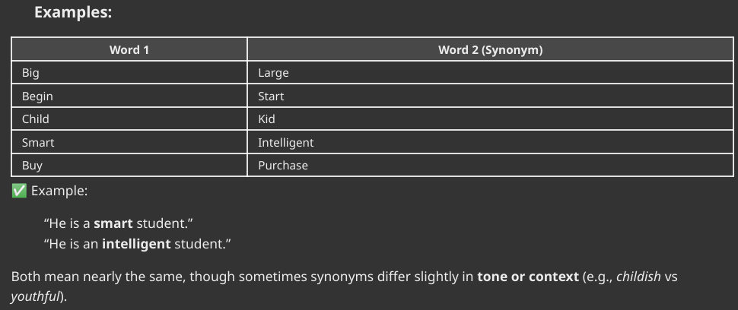

Conclusion
Understanding word relationships like hyponymy, polysemy, homonymy, and synonymy helps NLP systems interpret meaning, improve text retrieval, and enable better semantic analysis for translation and search tasks.

9. Describe the semantic analysis in Natural Language Processing.
Semantic analysis is the process in natural language processing (NLP) that focuses on understanding the meaning of words, phrases, and sentences by analyzing the relationships between them and considering the context.
Its goal is to enable machines to interpret and comprehend human language, much like a human would, by going beyond syntax to identify the true intent and meaning behind the text.
This is essential for applications like chatbots, search engines, and other AI systems that need to interpret and respond to user input accurately.

Key aspects of semantic analysis
- Contextual understanding:
It determines the correct meaning of words in a given context, which is crucial for handling ambiguity and words with multiple meanings (homonyms). For example, it distinguishes "rock" as a musical genre from "rock" as a mineral.
- Meaning extraction:
The process extracts key information like sentiment, emotions, and the relationships between concepts from unstructured text.
- Compositionality:
It focuses on how the meaning of individual words combines to create the meaning of larger units, like sentences.
- Relationship identification:
It identifies relationships between different pieces of data, helping to make sense of vast amounts of information and aiding in decision-making.

How it works
- Machine learning models:
Many modern systems use machine learning models trained on massive text datasets to uncover patterns and predict meaning.
- Structured data:
Alternatively, algorithms can use pre-defined knowledge bases and ontologies to help them interpret text by matching it to established concepts and relationships.
- Lexical semantics:
A component of semantic analysis, this subfield focuses specifically on the meaning of individual words and the relationships between them, such as synonyms and antonyms.

10.Explain Supervised Learning approach applied for word sense disambiguation.
Introduction
Supervised learning-based Word Sense Disambiguation uses labeled datasets where each word occurrence is tagged with its correct sense. The model learns from these examples to predict senses for new contexts.

Main Content
1. Training Phase
- Collect a corpus where words are manually annotated with senses.
- Extract contextual features (surrounding words, POS tags, syntactic relations).
- Train classifiers like Naïve Bayes, Decision Trees, SVM, or Neural Networks.

2. Testing Phase
- For an unseen sentence, extract features similarly.
- The model predicts the most likely sense based on learned patterns.

3. Example
Word: bank
Training sentences labeled as “river side” or “financial institution.”
During testing, “He went to the bank to deposit money” → predicted as financial institution.

4. Features Used
- Surrounding words (context window)
- POS tags
- Collocations
- Syntactic dependencies

5. Advantages
- High accuracy when sufficient annotated data is available.
- Adaptable to domain-specific usage.

6. Disadvantages
- Requires large sense-annotated corpora.
- Limited generalization to unseen senses.

7. Applications
Machine translation, information retrieval, and question answering benefit from accurate WSD.

Conclusion
Supervised WSD trains models to recognize sense distinctions based on labeled examples, providing high accuracy in controlled domains. Despite data requirements, it remains a powerful approach forming the basis for modern neural WSD systems.

